

**SUFLIX: Movie Rental Database Management System**

Aysun Öğüt 26609

Berke Turanlıoğlu 28442

Doruk Can Metiner 28271

Ömer Cem Tabar 25031

**New Create Table Queries:**

**Main Data Tables:**

CREATE TABLE Users (

name VARCHAR(50) NOT NULL,

password CHAR(20) NOT NULL,

id INT NOT NULL AUTO_INCREMENT,

PRIMARY KEY (id)

);

CREATE TABLE Movie (

movie_id INT NOT NULL AUTO_INCREMENT,

movie_name VARCHAR(30),

movie_description VARCHAR(250),

writer VARCHAR(30),

director VARCHAR(30),

stars VARCHAR(60),

release_year DATE,

running_time INTEGER,

main_category VARCHAR(30),

sub_category_one VARCHAR(30),

sub_category_two VARCHAR(30),

PRIMARY KEY (movie_id)

);

CREATE TABLE Customer (

id INT NOT NULL AUTO_INCREMENT,

username VARCHAR(30),

sex VARCHAR(6),

phone_number INTEGER(10),

birth_date DATE,

country VARCHAR(30),

category_liked_one VARCHAR(50),

category_liked_two VARCHAR(50),

PRIMARY KEY (id),

FOREIGN KEY(id)

REFERENCES Users(id)

ON DELETE CASCADE

);

CREATE TABLE Shopping_Cart (

cart_id INT NOT NULL AUTO_INCREMENT,

total_amount DOUBLE,

no_of_movies INTEGER,

PRIMARY KEY (cart_id));

CREATE TABLE Payment (

Payment_id INT NOT NULL AUTO_INCREMENT,

paymentcard_enddate VARCHAR(7),

paymentcard_type VARCHAR(11),

paymentcard_number CHAR(16),

paymentcard_fullname CHAR(25),

paymentcard_cvv CHAR(3),

PRIMARY KEY (payment_id));

CREATE TABLE Feedback(

feedback_id INT NOT NULL AUTO_INCREMENT,

comment CHAR(255),

rating DOUBLE,

PRIMARY KEY (feedback_id)

);

**Relation Tables:**

CREATE TABLE Producer_Adds (

id INT NOT NULL AUTO_INCREMENT,

movie_id INT NOT NULL,

PRIMARY KEY (id, movie_id),

FOREIGN KEY(id)

REFERENCES Users(id),

FOREIGN KEY(movie_id)

REFERENCES Movie(movie_id)

ON DELETE CASCADE

);

CREATE TABLE Done_For(

payment_id INT NOT NULL,

cart_id INT NOT NULL,

PRIMARY KEY (payment_id, cart_id),

FOREIGN KEY (payment_id)

REFERENCES Payment(payment_id),

FOREIGN KEY(cart_id)

REFERENCES Shopping_Cart(cart_id)

ON DELETE CASCADE

);

CREATE TABLE Does (

payment_id INT NOT NULL,

id INT NOT NULL,

PRIMARY KEY (payment_id, id),

FOREIGN KEY (payment_id)

REFERENCES Payment(payment_id),

FOREIGN KEY(id)

REFERENCES Users(id)

ON DELETE CASCADE

);

CREATE TABLE Rents(

movie_id INT NOT NULL,

id INT NOT NULL,

PRIMARY KEY (movie_id, id),

FOREIGN KEY(movie_id)

REFERENCES Movie(movie_id),

FOREIGN KEY(id)

REFERENCES Users(id)

ON DELETE CASCADE

);

CREATE TABLE Gives(

feedback_id INT NOT NULL,

id INT NOT NULL,

PRIMARY KEY (feedback_id, id),

FOREIGN KEY(feedback_id)

REFERENCES Feedback(feedback_id),

FOREIGN KEY(id)

REFERENCES Customer(id)

ON DELETE CASCADE

);

CREATE TABLE Contains(

feedback_id INT NOT NULL,

movie_id INT NOT NULL,

PRIMARY KEY (feedback_id, movie_id),

FOREIGN KEY(feedback_id)

REFERENCES Feedback(feedback_id),

FOREIGN KEY (movie_id)

REFERENCES Movie(movie_id)

ON DELETE CASCADE

);

CREATE TABLE Added_To(

movie_id INT NOT NULL,

cart_id INT NOT NULL,

PRIMARY KEY (movie_id, cart_id),

FOREIGN KEY(movie_id)

REFERENCES Movie(movie_id),

FOREIGN KEY(cart_id)

REFERENCES Shopping_Cart(cart_id)

ON DELETE CASCADE

);

CREATE TABLE Has(

cart_id INT NOT NULL,

id INT NOT NULL,

PRIMARY KEY (cart_id, id),

FOREIGN KEY(cart_id)

REFERENCES Shopping_Cart(cart_id),

FOREIGN KEY(id)

REFERENCES Users(id)

ON DELETE CASCADE

);

**Movie Data Table Insert Statements:**

* **Remark!** Since we have changed the structure of the tables, now all id related attributes are auto generated and incremented accordingly whenever a new entry is created. So for convenience, while writing queries we didn’t add any id related attributes. They will be generated and incremented accordingly.

INSERT INTO Movie ( movie_name, movie_description, writer, director, stars, release_year, running_time, main_category, sub_category_one, sub_category_two)

VALUES ('Ghostbusters: Afterlife', 'When a single mom and her two kids arrive in a small town, they begin to discover their connection to the original Ghostbusters and the secret legacy their grandfather left behind.', 'Gil Kenan, Jason Reitman, Dan Aykroyd', 'Jason Reitman', 'Carrie Coon, Paul Rudd, Finn Wolfhard, Mckenna Grace, Bill Murray', '2021-01-01', '124', 'Adventure', 'Comedy', 'Fantasy');

INSERT INTO Movie ( movie_name, movie_description, writer, director, stars, release_year, running_time, main_category, sub_category_one, sub_category_two)

VALUES ('Dune: Part One', 'Feature adaptation of Frank Herbert\'s science fiction novel, about the son of a noble family entrusted with the protection of the most valuable asset and most vital element in the galaxy..', '[Jon Spaihts](https://www.imdb.com/name/nm3123612/?ref_=tt_ov_wr), [Denis Villeneuve](https://www.imdb.com/name/nm0898288/?ref_=tt_ov_wr), [Eric Roth](https://www.imdb.com/name/nm0744839/?ref_=tt_ov_wr), Frank Herbert', 'Denis Villeneuve', 'Timothée Chalamet, Rebecca Ferguson, Oscar Isaac, Jason Momoa, Zendaya', '2021-01-01', '155', 'Action', 'Adventure', 'Drama');

INSERT INTO Movie ( movie_name, movie_description, writer, director, stars, release_year, running_time, main_category, sub_category_one, sub_category_two)

VALUES ('No Time to Die', 'James Bond has left active service. His peace is short-lived when Felix Leiter, an old friend from the CIA, turns up asking for help, leading Bond onto the trail of a mysterious villain armed with dangerous new technology.', 'Neal Purvis, Robert Wade, Cary Joji Fukunaga', 'Cary Joji Fukunaga', 'Daniel Craig, Léa Seydoux, Rami Malek, Ana de Armas, Ralph Fiennes', '2021-01-01', '163', 'Action', 'Adventure', 'Thriller');

INSERT INTO Movie ( movie_name, movie_description, writer, director, stars, release_year, running_time, main_category, sub_category_one, sub_category_two)

VALUES ('Belfast', 'A young boy and his working class family experience the tumultuous late 1960s.', 'Kenneth Branagh', 'Kenneth Branagh', 'Jude Hill, Lewis McAskie, Caitriona Balfe, Jamie Dorman, Judi Dench', '2021-01-01', '98', 'Drama','','');

INSERT INTO Movie ( movie_name, movie_description, writer, director, stars, release_year, running_time, main_category, sub_category_one, sub_category_two)

VALUES ('Inception', 'A thief who steals corporate secrets through the use of dream-sharing technology is given the inverse task of planting an idea into the mind of a C.E.O., but his tragic past may doom the project and his team to disaster.', 'Christopher Nolan', 'Christopher Nolan', 'Leonardo DiCaprio, Joseph Gordon-Levitt, Elliot Page, Tom Hardy, Cillian Murphy', '2010-01-01', '148', 'Action', 'Adventure', 'Sci-Fi');

INSERT INTO Movie ( movie_name, movie_description, writer, director, stars, release_year, running_time, main_category, sub_category_one, sub_category_two)

VALUES ('The Shawshank Redemption', 'Two imprisoned men bond over a number of years, finding solace and eventual redemption through acts of common decency.', 'Stephen King, Frank Darabont', ' Frank Darabont', 'Tim Robbins, Morgan Freeman, Bob Gunton', '1994-01-01', '142', 'Drama', '', '');

**User Data Table Insert Statements:**

INSERT INTO Users (name, password)

VALUES ('Ahmet Ozturk', '123456');

INSERT INTO Users (name, password)

VALUES ('Ayse Demir', 'qwerty');

INSERT INTO Users (name, password)

VALUES ('Hasan Yilmaz', 'password');

INSERT INTO Users (name, password)

VALUES ('Can Arslan', 'pass123123');

INSERT INTO Users (name, password)

VALUES ('Ece Gokturk', 'cs306password');

INSERT INTO Users (name, password)

VALUES ('Eda Bediha', '11223344');

INSERT INTO Users (name, password)

VALUES ('Arda Uykulu', 'uykuluarda11');

**Customer Data Table Insert Statements:**

INSERT INTO Customer (username, sex, phone_number, birth_date, country, category_liked_one, category_liked_two)

VALUES ('ahmetozturk2', 'male', '5555555555', '1990-04-02', 'Turkey', 'Action', 'Drama');

INSERT INTO Customer (username, sex, phone_number, birth_date, country, category_liked_one, category_liked_two)

VALUES ('ayse123', 'female', '5554444444', '1996-10-12', 'Turkey', 'Adventure', 'Drama');

INSERT INTO Customer (username, sex, phone_number, birth_date, country, category_liked_one, category_liked_two)

VALUES ('hasanylmz', 'male', '5553333333', '2001-09-06', 'Turkey', 'Sci-Fi', 'Adventure');

INSERT INTO Customer (username, sex, phone_number, birth_date, country, category_liked_one, category_liked_two)

VALUES ('can1907', 'male', '5552222222', '2000-03-07', 'Turkey', 'Crime', 'Drama');

INSERT INTO Customer (username, sex, phone_number, birth_date, country, category_liked_one, category_liked_two)

VALUES ('ecegokturk123', 'female', '5551111111', '1987-04-20', 'Turkey', 'Romance', 'Drama');

INSERT INTO Customer (username, sex, phone_number, birth_date, country, category_liked_one, category_liked_two)

VALUES ('bedda', 'female', '5520010101', '1993-02-18', 'Turkey', 'Sci-Fi', 'Adventure');

INSERT INTO Customer (username, sex, phone_number, birth_date, country, category_liked_one, category_liked_two)

VALUES ('sleepyarda', 'male', '5474704770', '2001-11-14', 'Turkey', 'Crime', 'Romance');

**Shopping Cart Data Table Insert Statements:**

INSERT INTO Shopping_Cart (total_amount, no_of_movies)

VALUES ('77.25', '3');

INSERT INTO Shopping_Cart (total_amount, no_of_movies)

VALUES ('40', '5');

INSERT INTO Shopping_Cart (total_amount, no_of_movies)

VALUES ('10', '1');

INSERT INTO Shopping_Cart (total_amount, no_of_movies)

VALUES ('24', '4');

INSERT INTO Shopping_Cart (total_amount, no_of_movies)

VALUES ('98.11', '14');

INSERT INTO Shopping_Cart (total_amount, no_of_movies)

VALUES ('30', '6');

**Payment Data Table Insert Statements:**

INSERT INTO Payment (paymentcard_enddate, paymentcard_type, paymentcard_number, paymentcard_fullname, paymentcard_cvv)

VALUES ('01/2022', 'Debit Card', '1111222233334444', 'Ahmet Ozturk', '111');

INSERT INTO Payment (paymentcard_enddate, paymentcard_type, paymentcard_number, paymentcard_fullname, paymentcard_cvv)

VALUES ('03/2025', 'Credit Card', '1234123412341234', 'Ayse Demir', '123');

INSERT INTO Payment (paymentcard_enddate, paymentcard_type, paymentcard_number, paymentcard_fullname, paymentcard_cvv)

VALUES ('12/2027', 'Credit Card', '5555666677778888', 'Hasan Yilmaz', '555');

INSERT INTO Payment (paymentcard_enddate, paymentcard_type, paymentcard_number, paymentcard_fullname, paymentcard_cvv)

VALUES ('06/2023', 'Debit Card', '5678567856785678', 'Can Arslan', '567');

INSERT INTO Payment (paymentcard_enddate, paymentcard_type, paymentcard_number, paymentcard_fullname, paymentcard_cvv)

VALUES ('09/2024', 'Credit Card', '1234567812345678', 'Ece Gokturk', '345');

INSERT INTO Payment (paymentcard_enddate, paymentcard_type, paymentcard_number, paymentcard_fullname, paymentcard_cvv)

VALUES ('05/2025', 'Credit Card', '4444090912110003', 'Eda Bediha', '910');

INSERT INTO Payment (paymentcard_enddate, paymentcard_type, paymentcard_number, paymentcard_fullname, paymentcard_cvv)

VALUES ('02/2022', 'Debit Card', '5555010012452233', 'Arda Uykulu', '313');

**Feedback Data Table Insert Statements:**

INSERT INTO Feedback (comment, rating)

VALUES ('Brilliant movie. Loved it.', '9.2');

INSERT INTO Feedback (comment, rating)

VALUES ('One word: terrible.', '4');

INSERT INTO Feedback (comment, rating)

VALUES ('Could’ve been better but okay.', '6.5');

INSERT INTO Feedback (comment, rating)

VALUES ('That movie got me thinking, nice one.', '7.7');

INSERT INTO Feedback (comment, rating)

VALUES ('Neutral.', '7');

**WEB PAGES**

* **Admin Panel**

Here is the view of the administrator panel of our project SUFLIX.



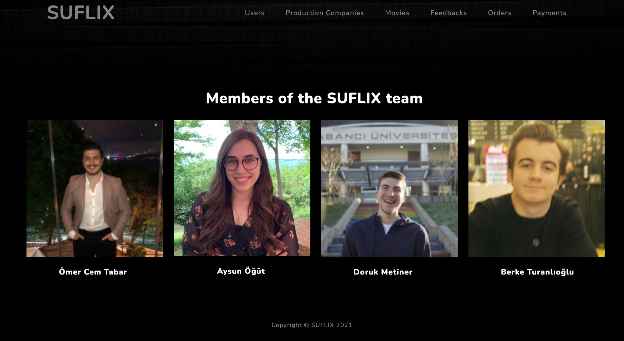

* **General View of Our Database**

Here is the general view of all of our tables with the corresponding insertions mentioned above.

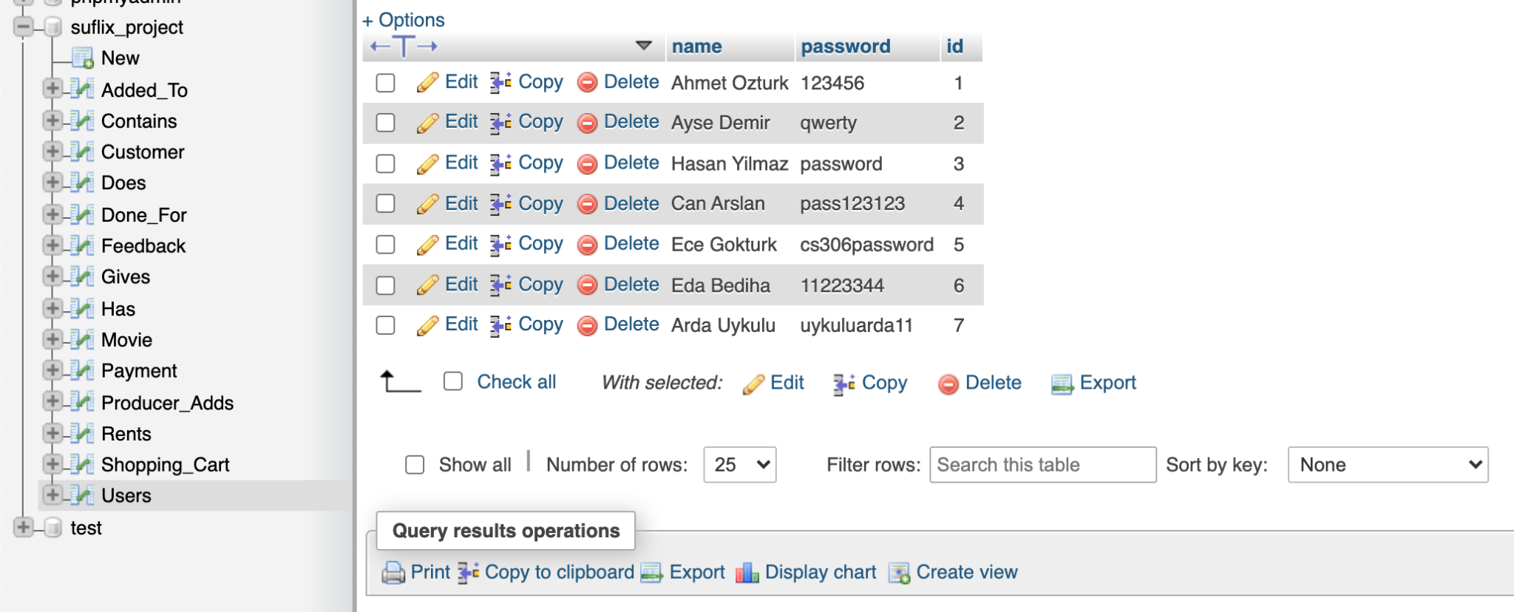

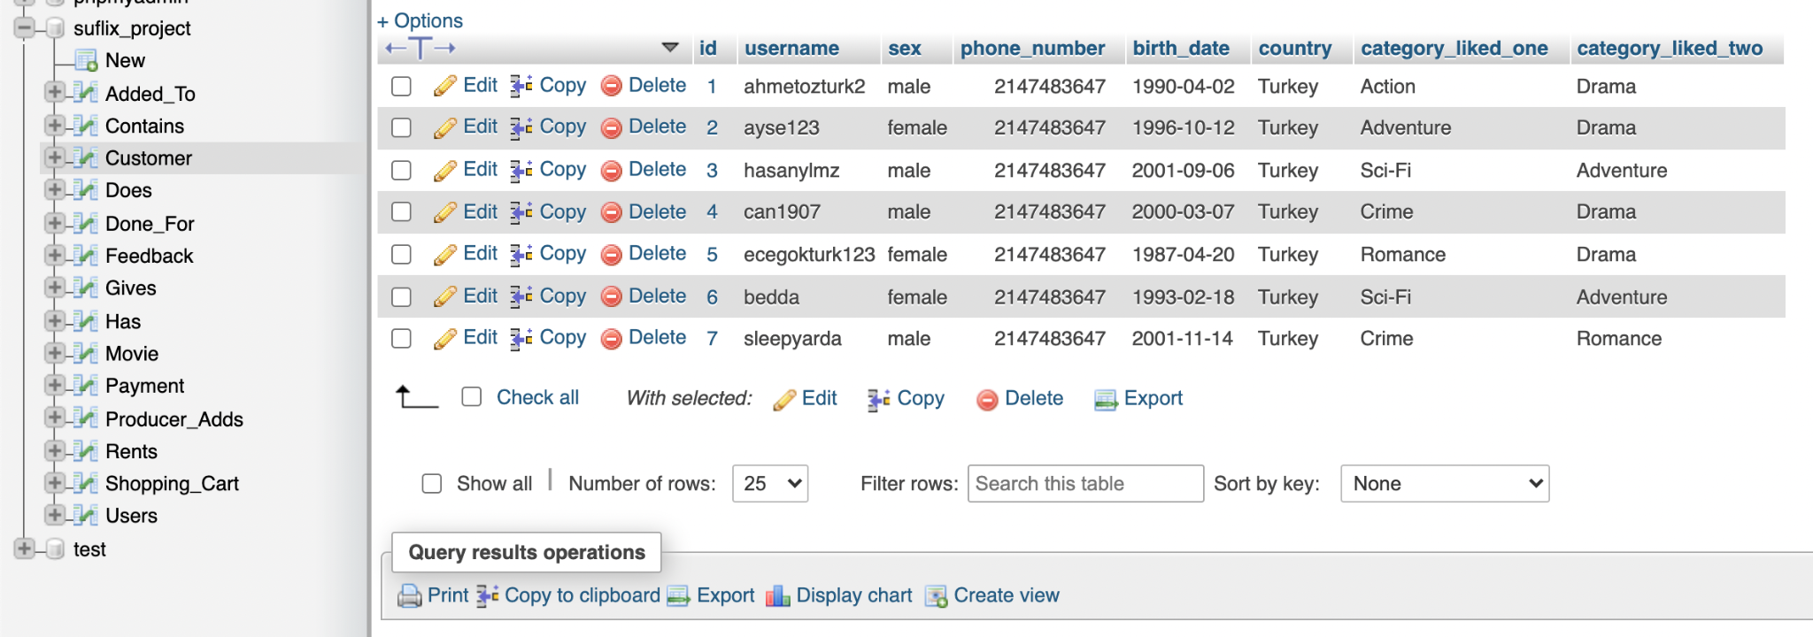

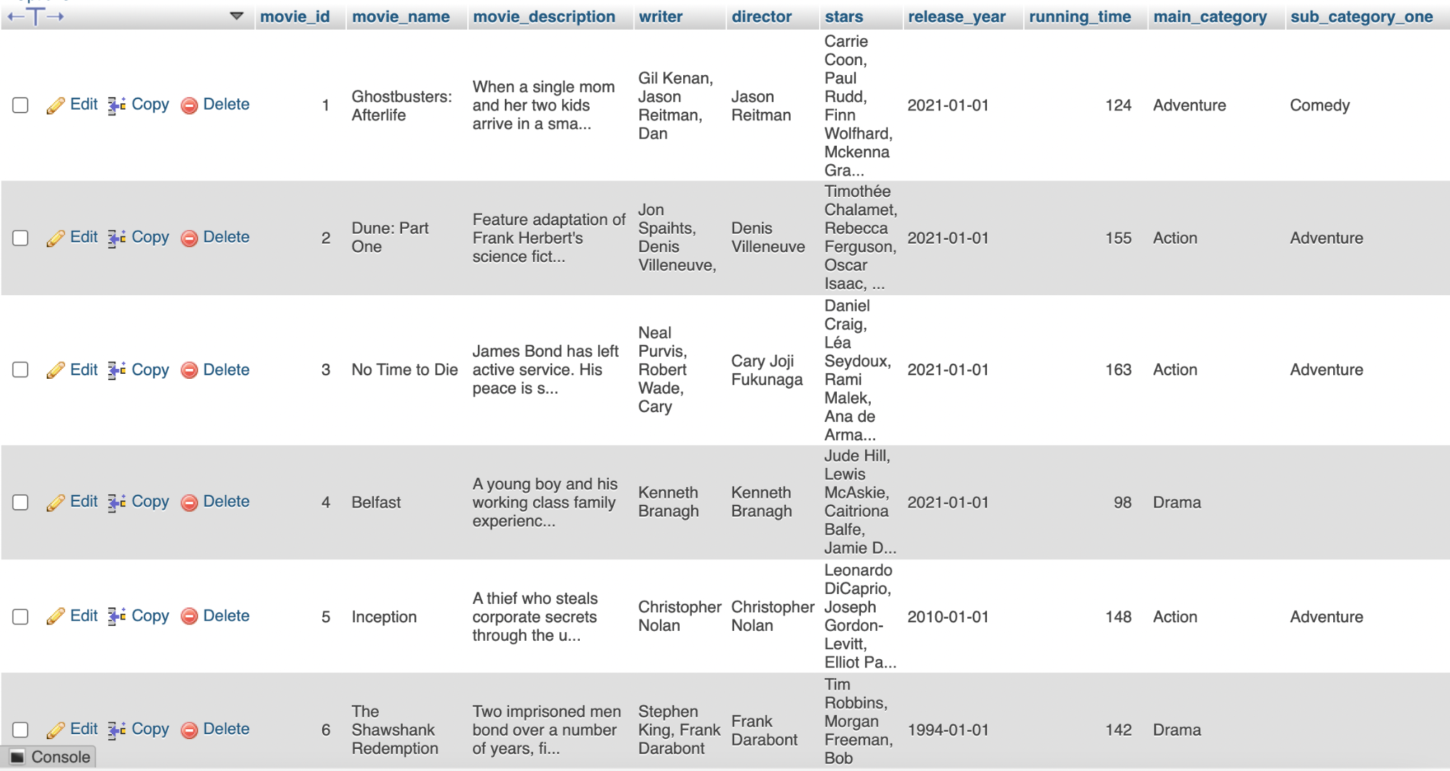

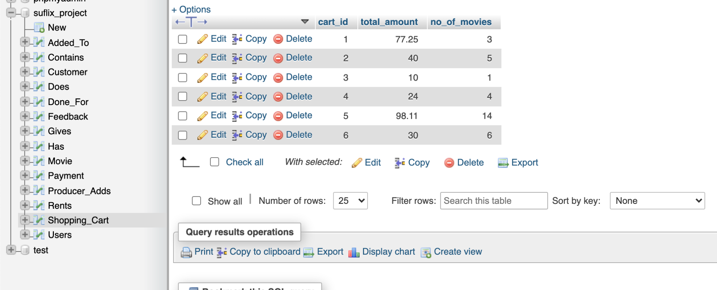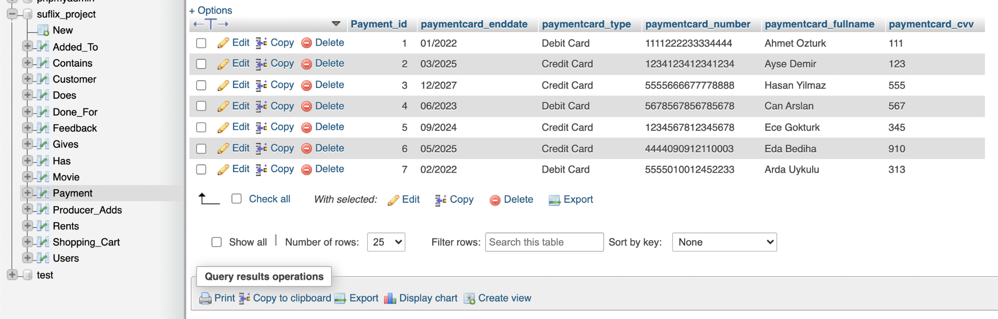

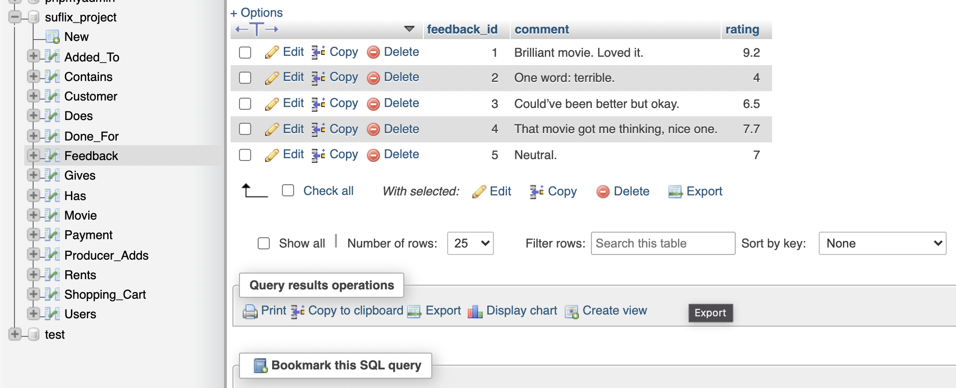

* **Insertion**

Next follows our insertion web pages, adding to the tables in our database.

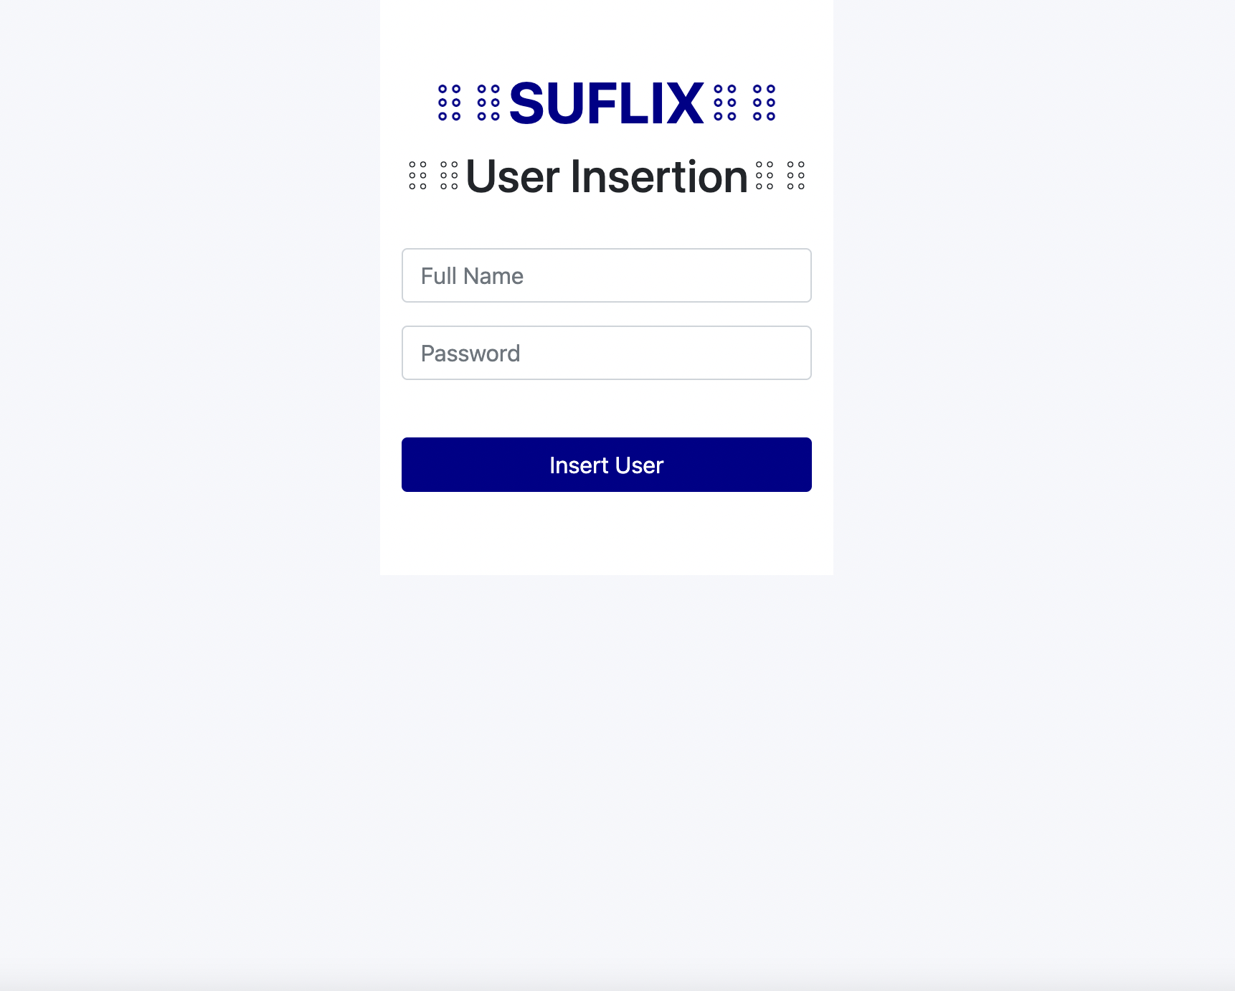

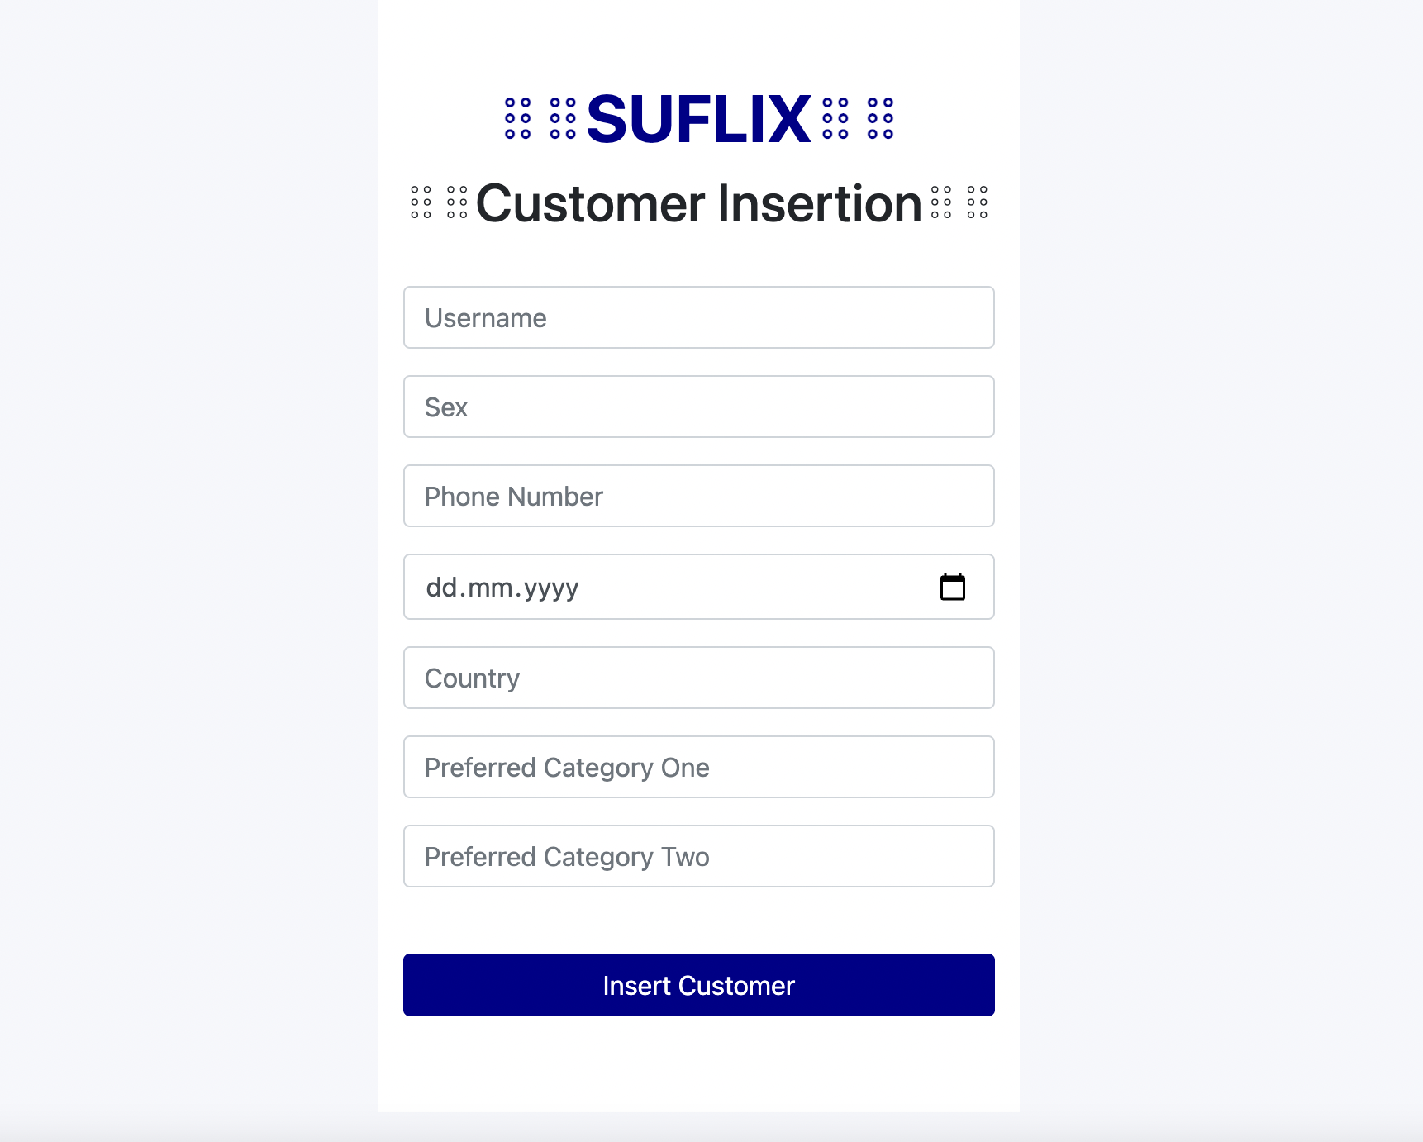



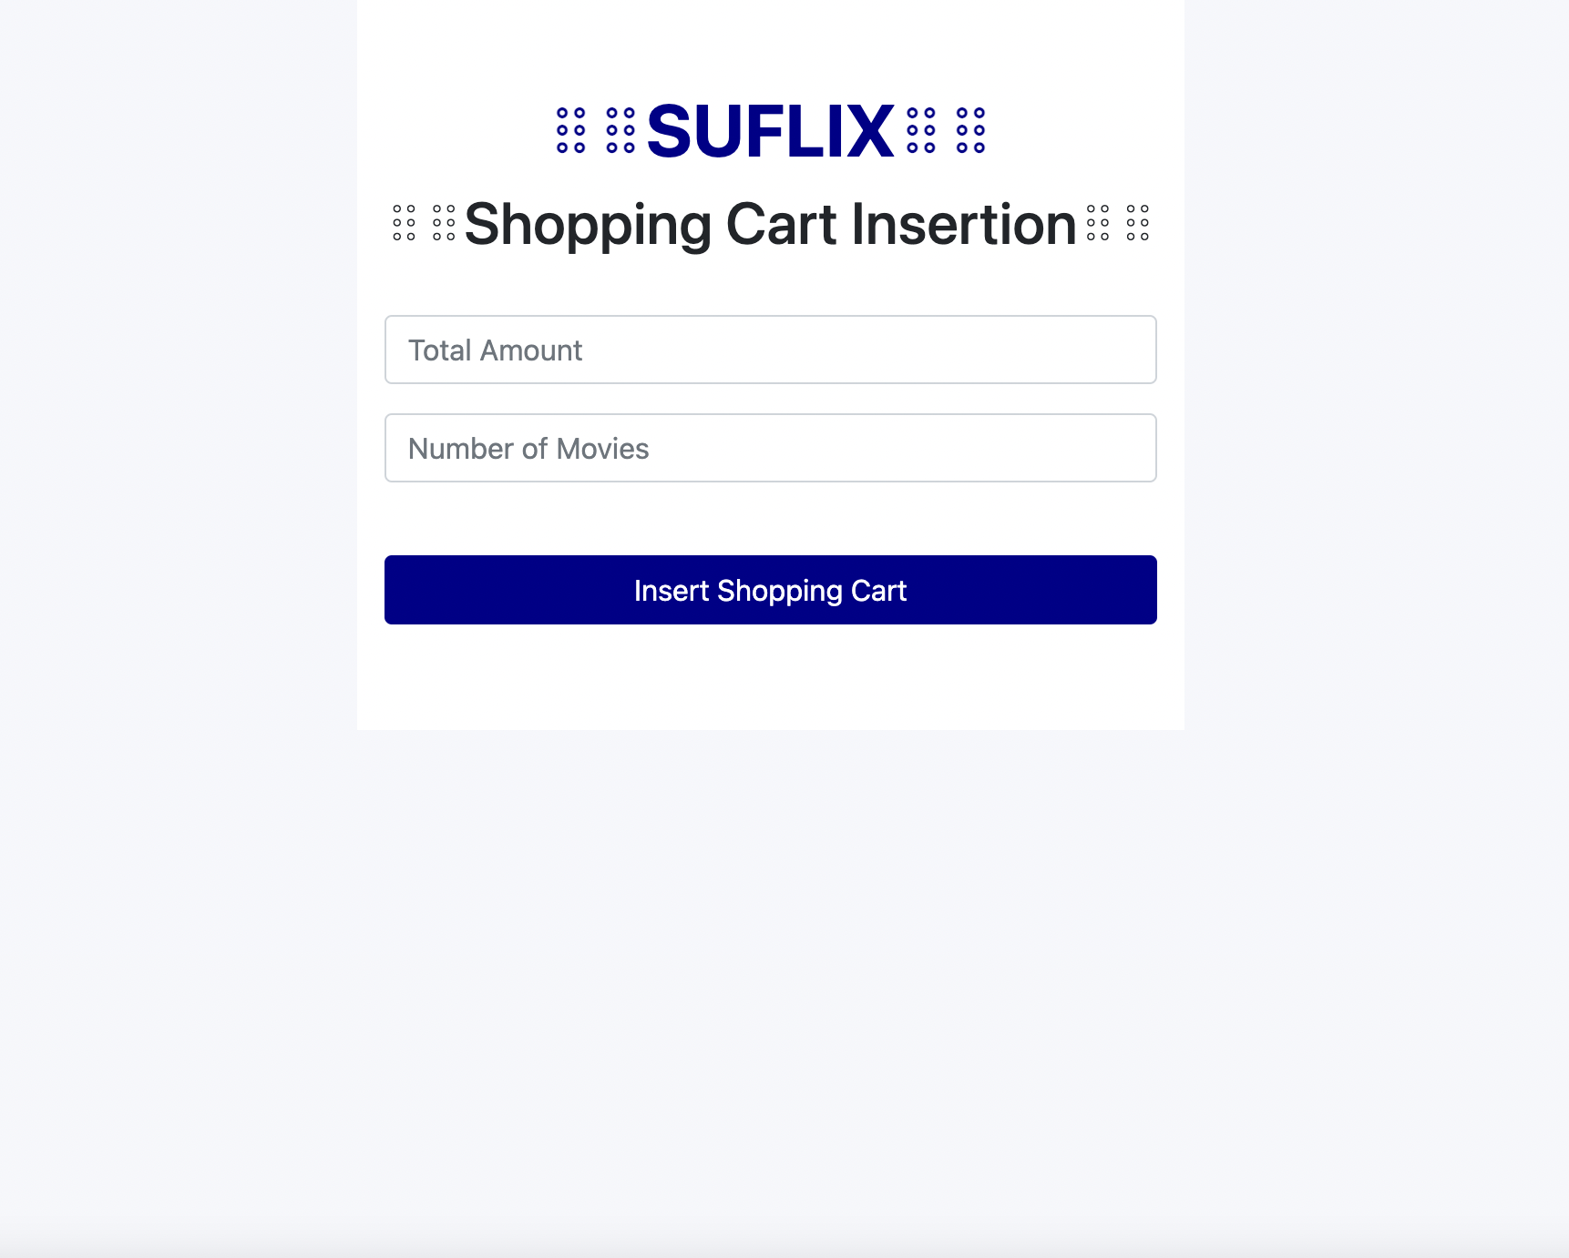



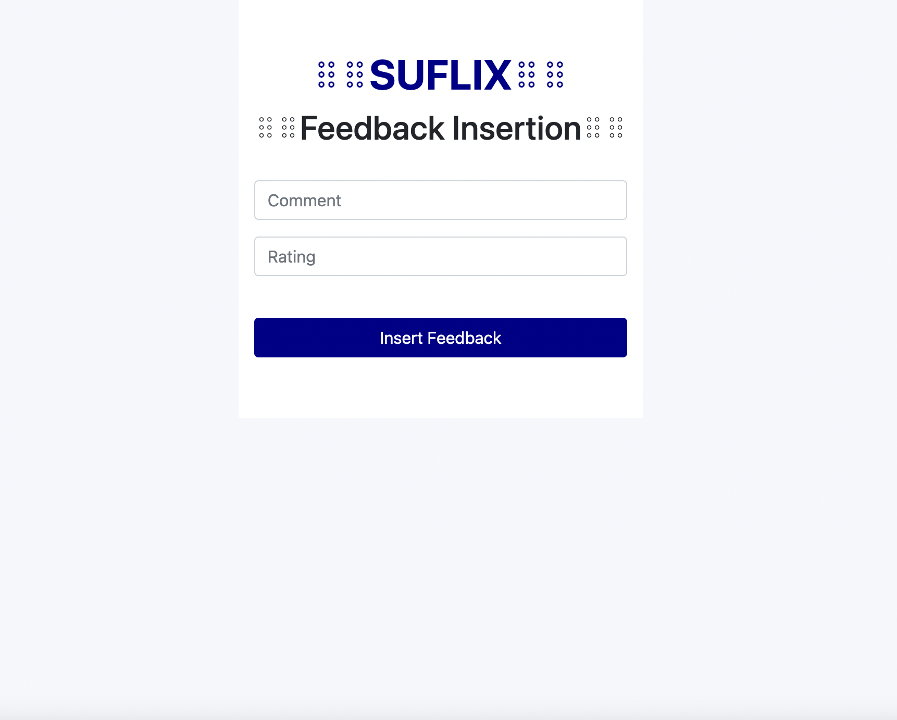

* **Deletion**

Following the insertion comes our deletion web pages, deleting from the tables in our database.

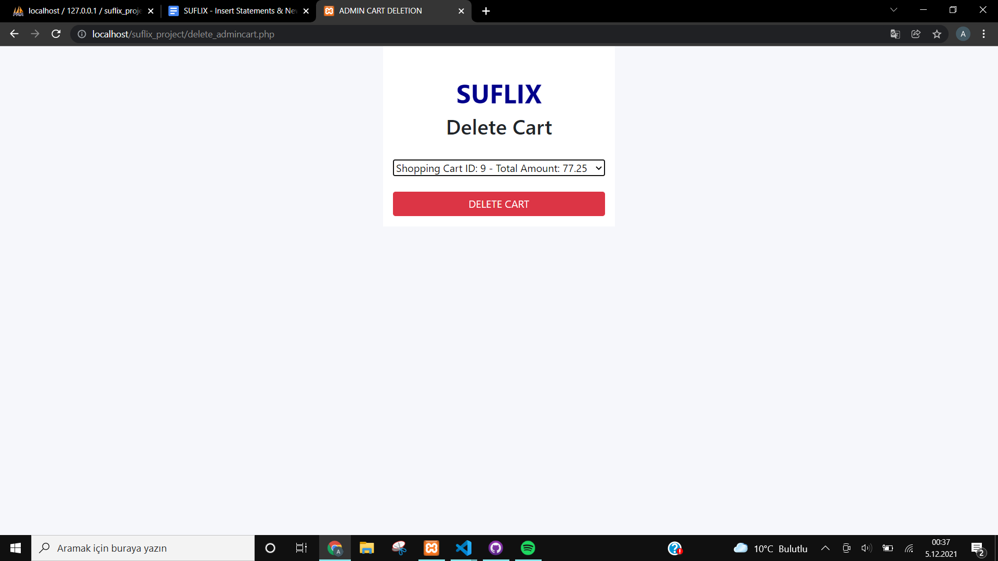

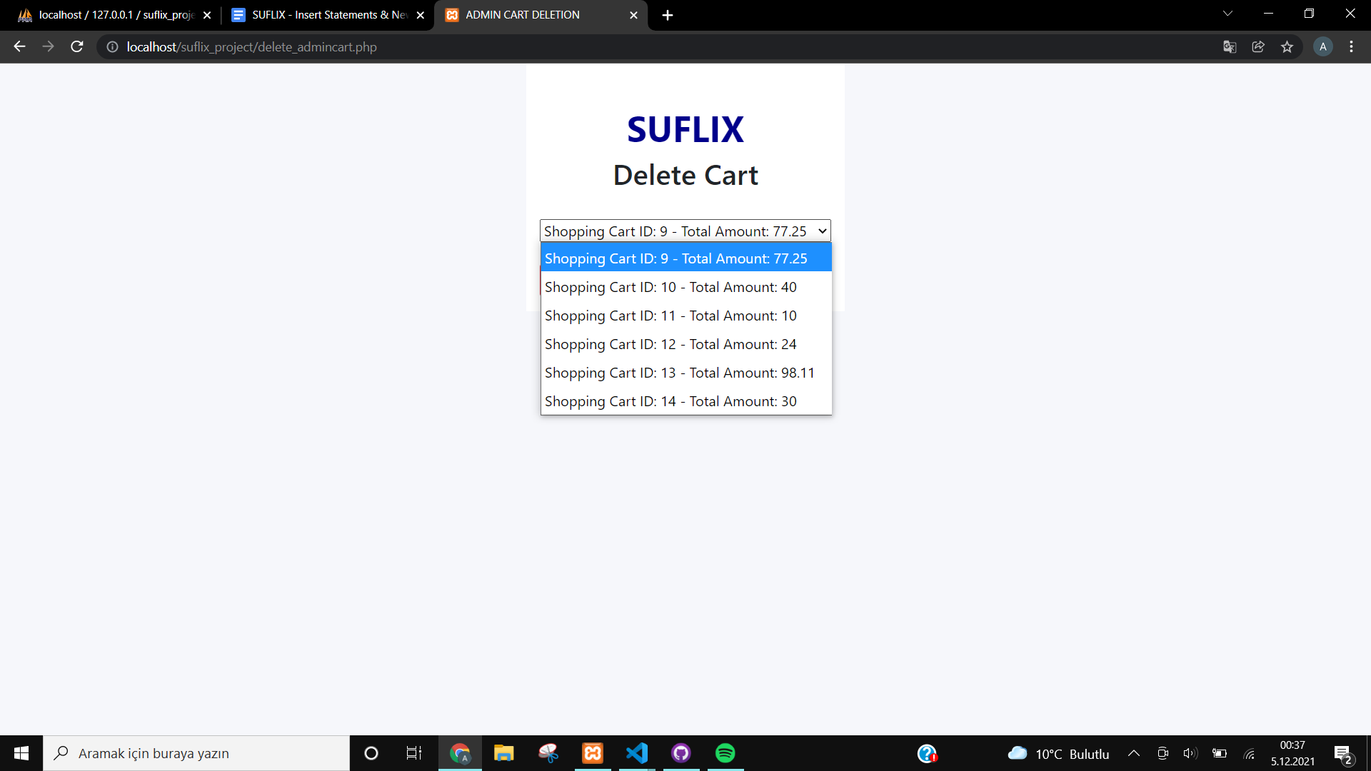

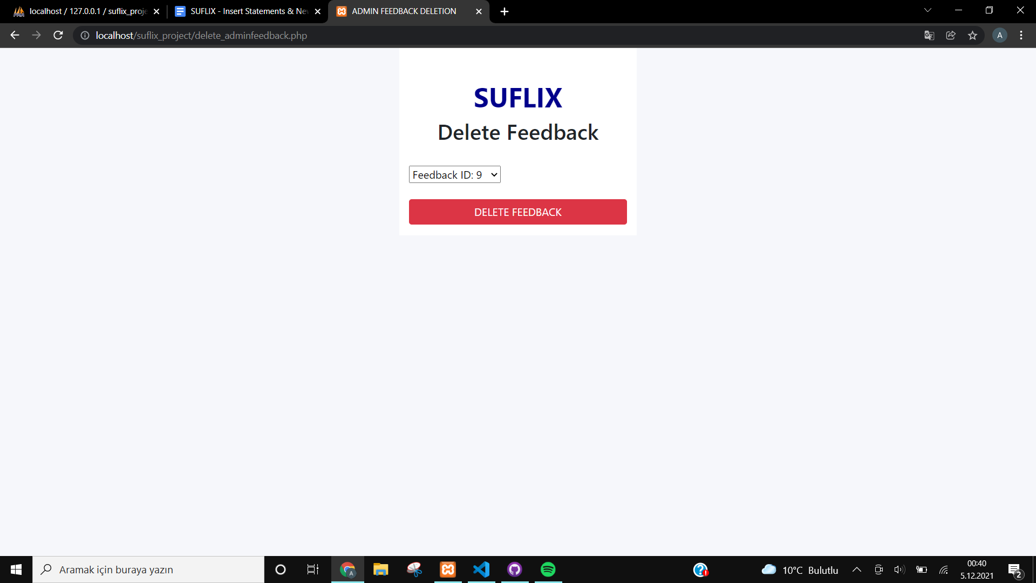

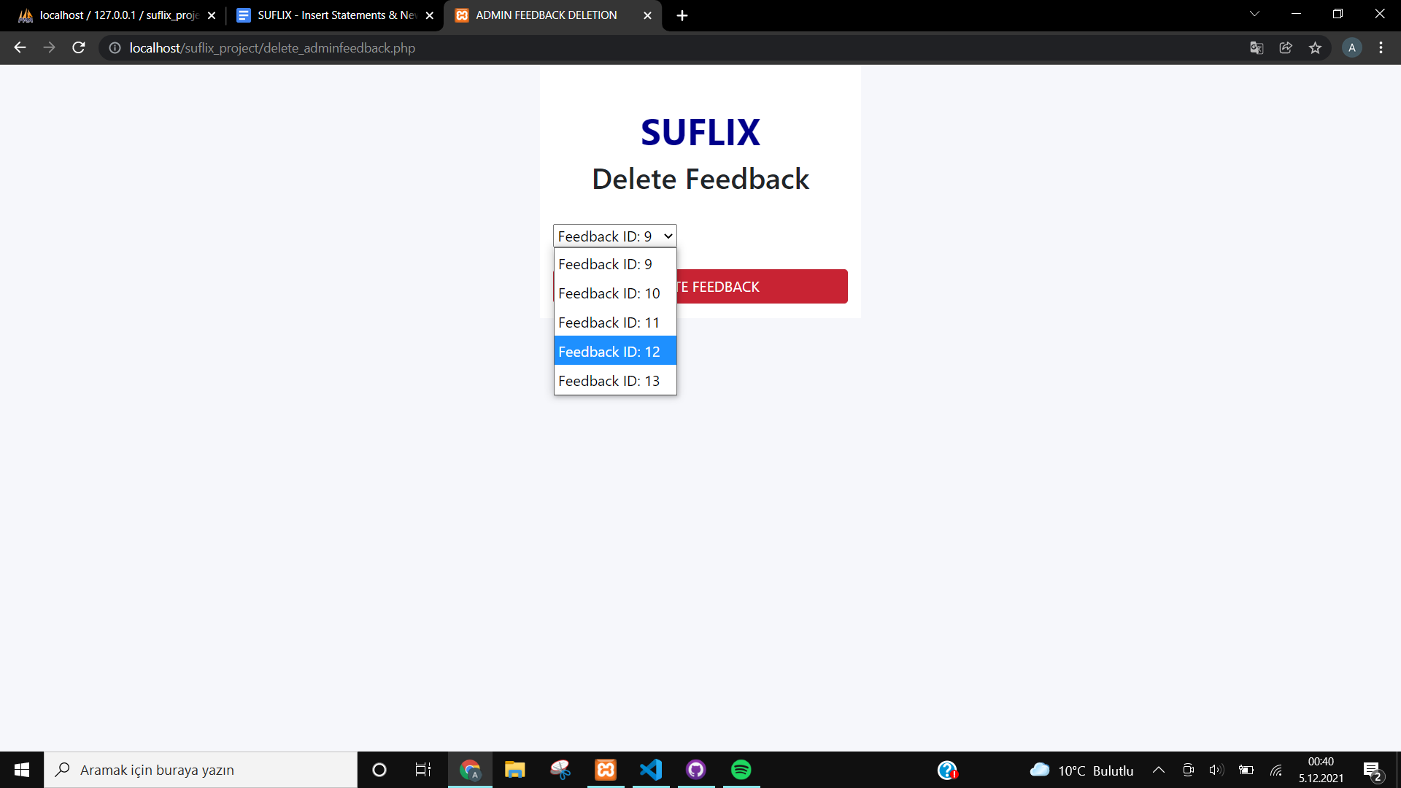

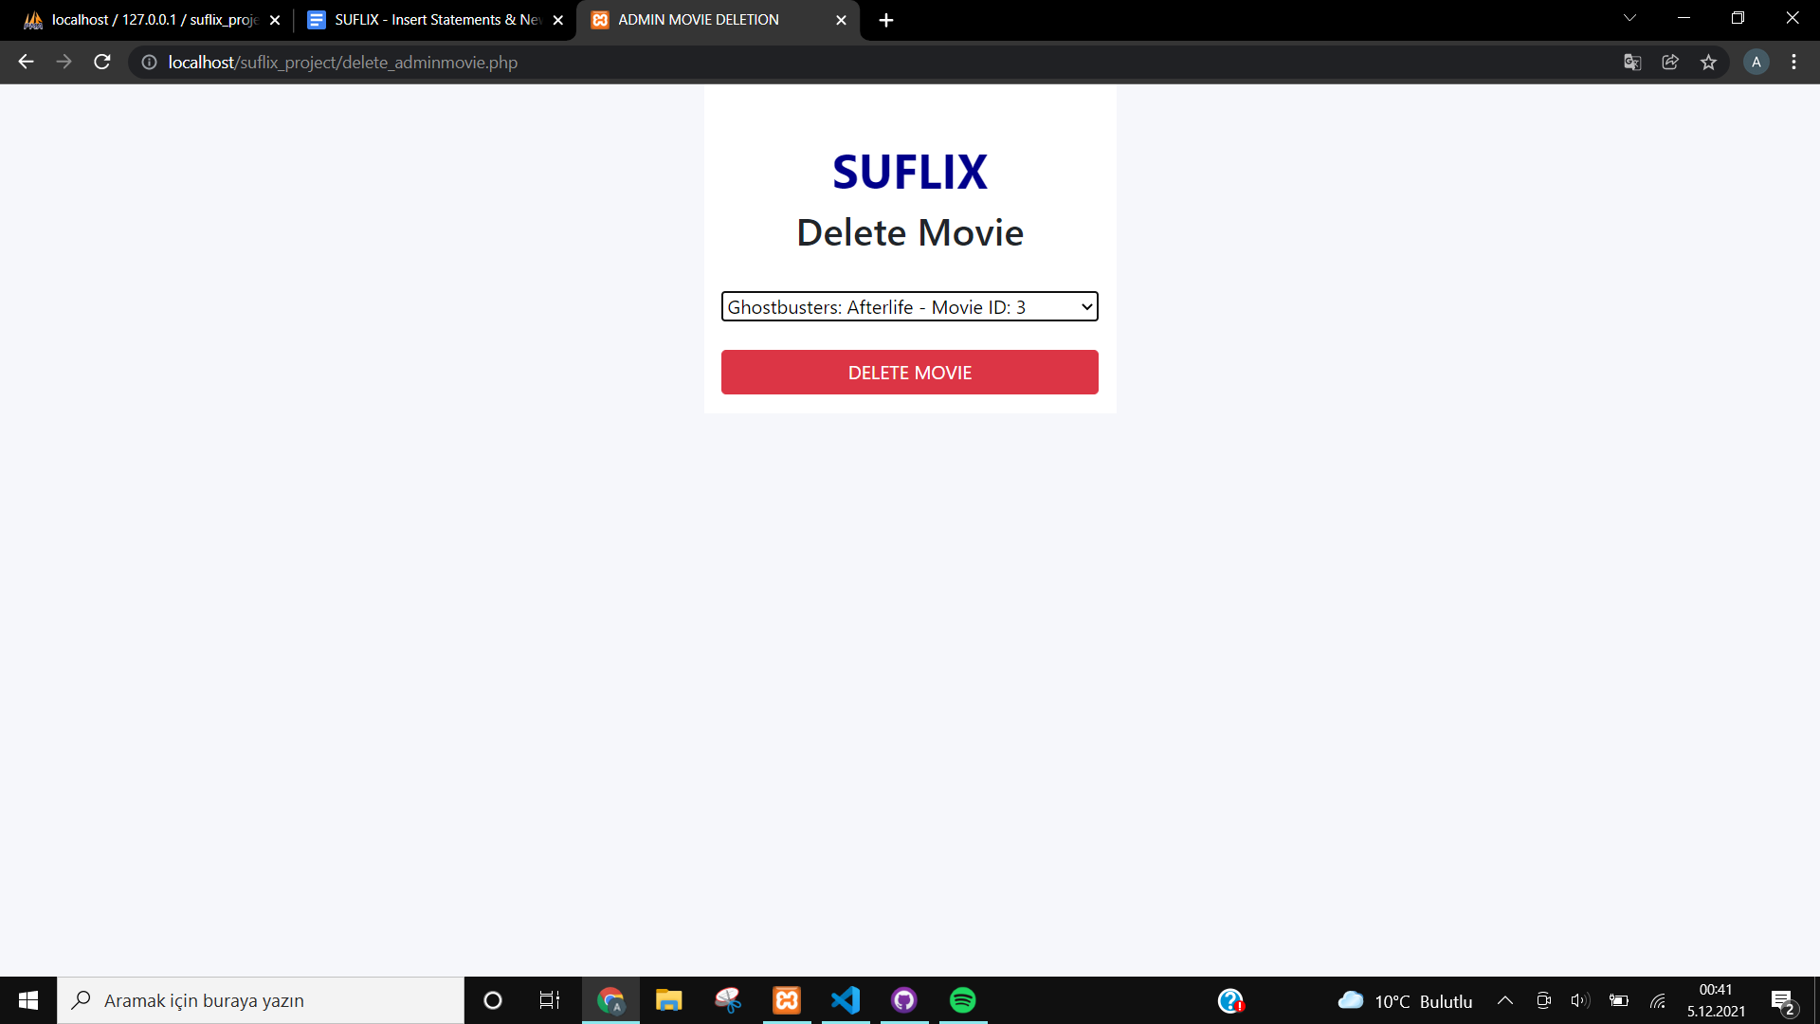

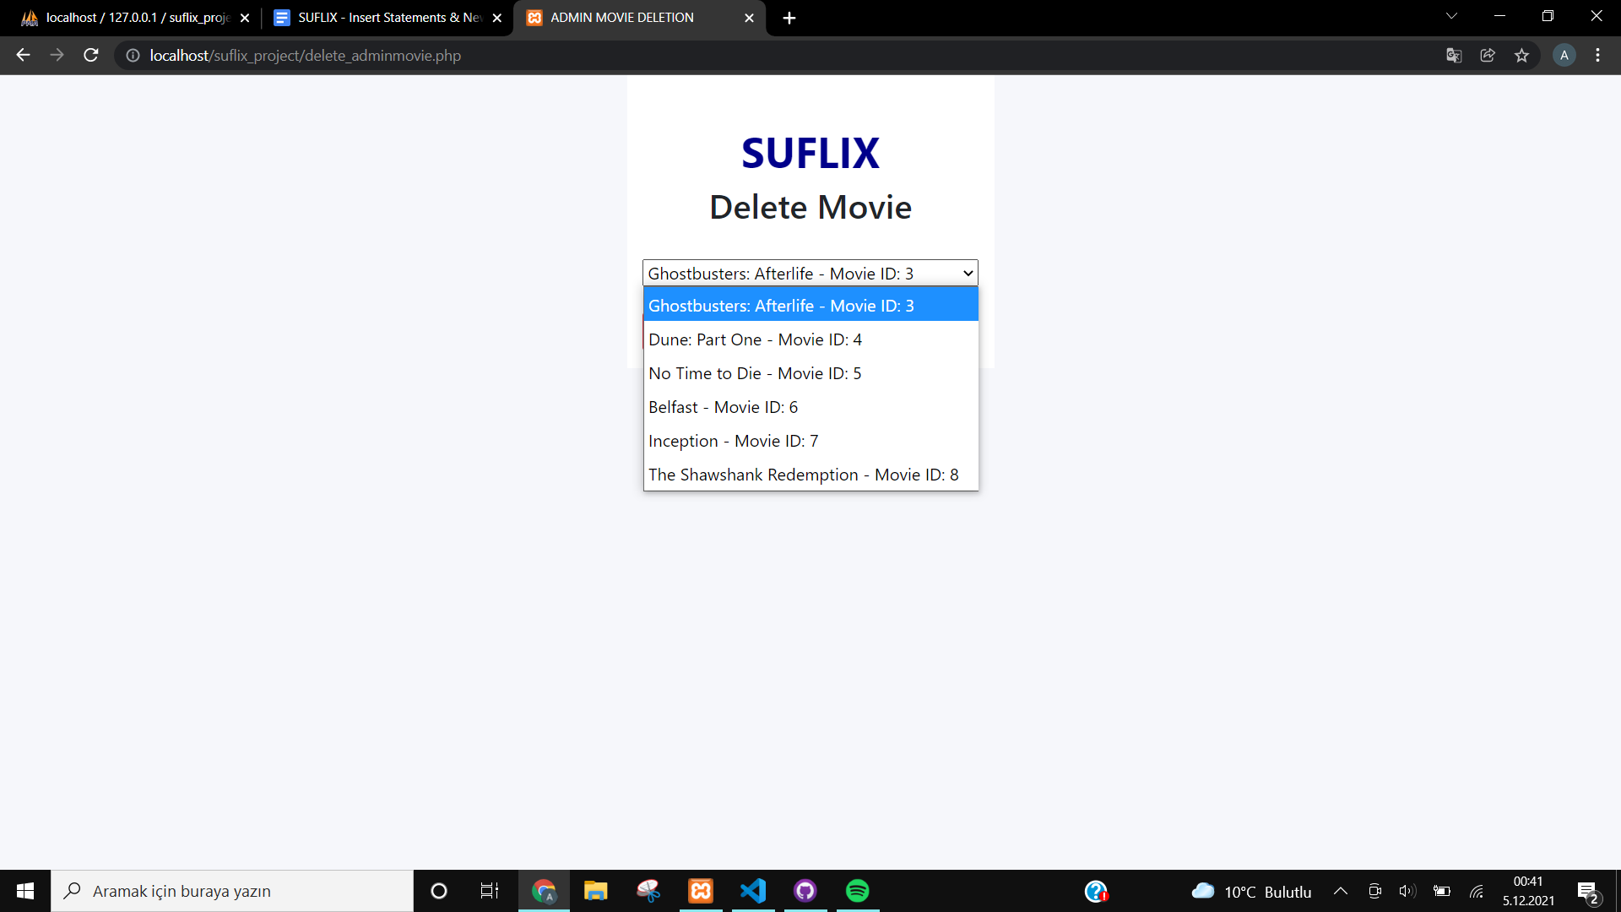

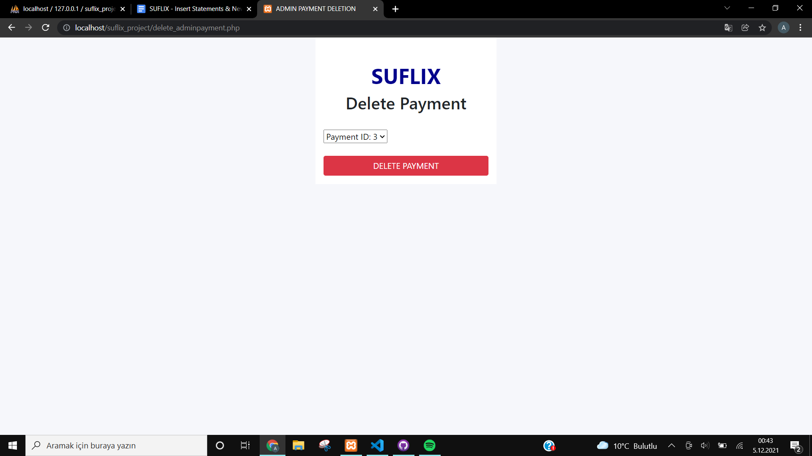

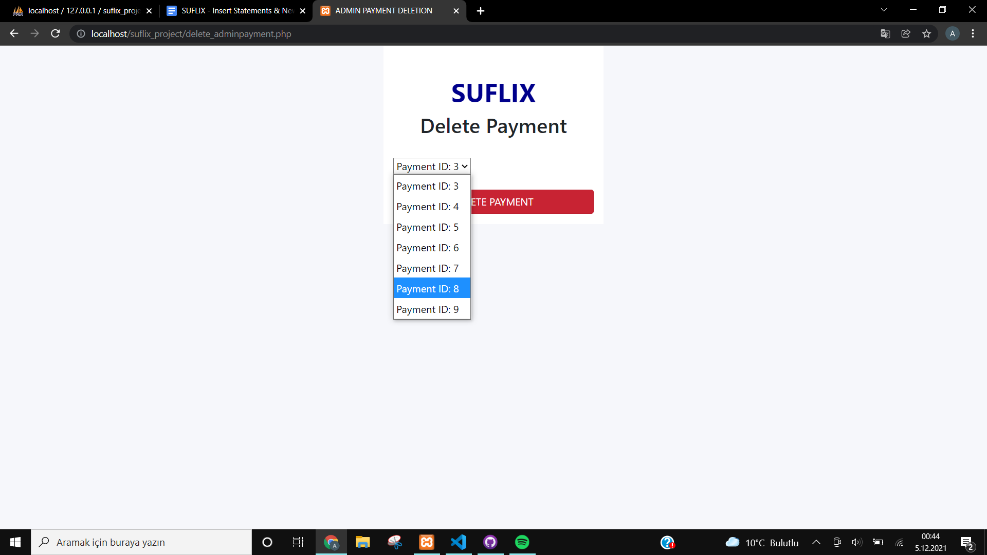

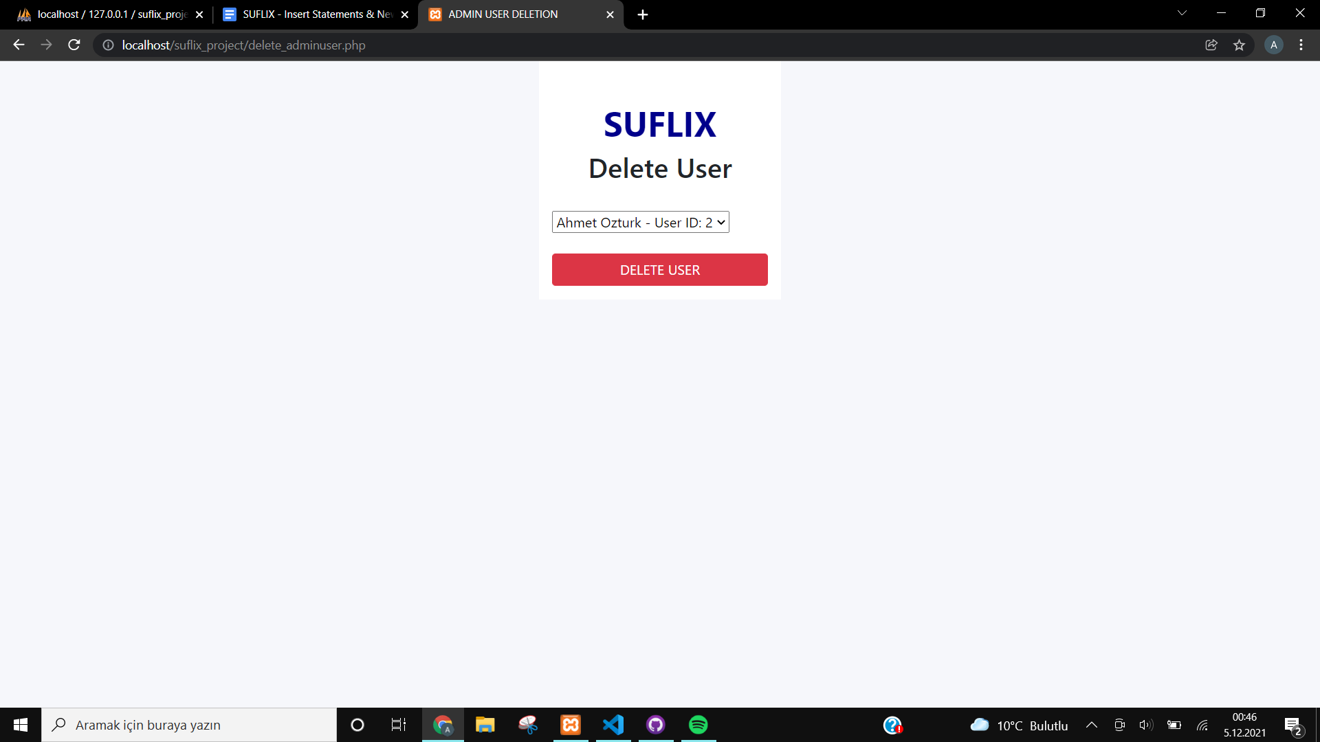

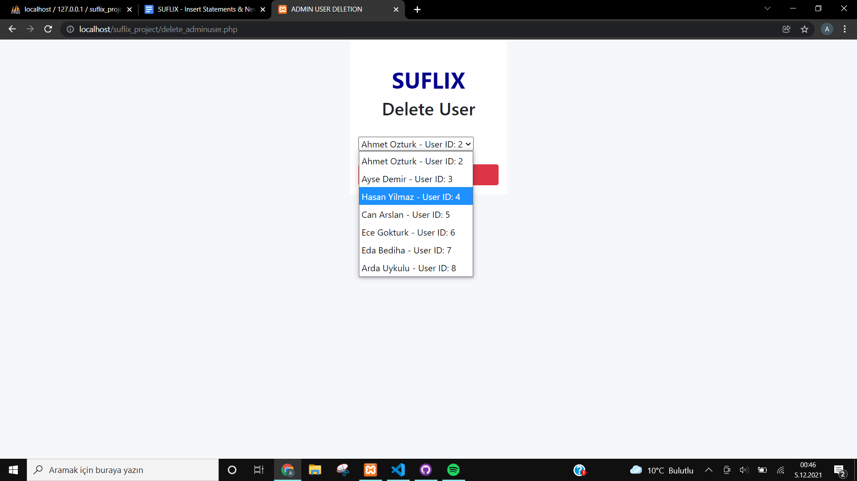

As an example, let’s delete ‘Can Arslan’:

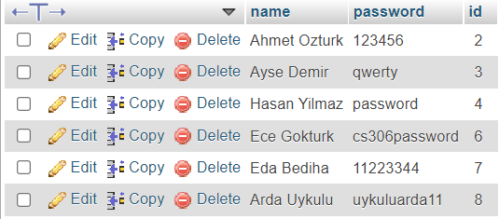

It correctly deletes from the database. Since all other deletion pages are made with the same code implementation, it works in the same way and therefore it correctly deletes from the database.

* **Selection**

Lastly comes our selection web pages, filtering the desired data and displaying to the administrator. We designed our selection web pages on our two main entities; user selection and movie selection.

